How to setup PYNQ board with precompiled image

* Requirement to operate pynq
  + Pynq board
  + Ethernet cable
  + USB cable or adaptor
  + Sd (with lat6est image file uploaded)
* First connect your board physically by connecting pynq board and router by ethernet cable.
* Second, to give power source connect via USB with the computer or by adapter directly.
* Third, Connect the pynq with the network Via ethernet cable:
  + First check the IP address of the board by installing ‘angryIP scanner’. The link is given below:
    - <https://angryip.org/download/#windows>
* You can see the following home page of AngryIP scanner



* Here you can see **start** tab . Click on the start tab to start scan of the available IP’s.
* You can see the name of your board with the IP address:



* Now as you can see the ip address enter the same address in the address bar in your browser
  + For example: 10.10.10.233:9090

or

* You can connect directly by typing PYNQ:9090
* Now you will see the home page of Jupyter:



* Here the password is **Xilinx.**
* Now you can see the home page of Jupyter of your board:

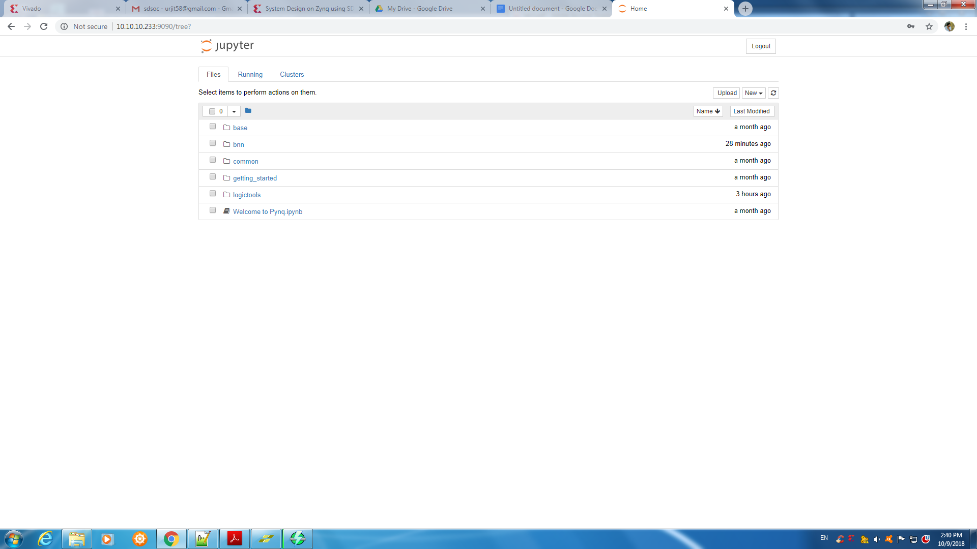

* Now here you need to download the image compatible with your board from:
  + [**PYNQ-Z1 v2.3**](http://files.digilent.com/Products/PYNQ/pynq_z1_v2.3.zip) **[PYNQ image](http://files.digilent.com/Products/PYNQ/pynq_z1_v2.3.zip)**
  + [**PYNQ-Z2 v2.3**](https://d2m32eurp10079.cloudfront.net/Download/pynq_z2_v2.3.zip) **[PYNQ image](https://d2m32eurp10079.cloudfront.net/Download/pynq_z2_v2.3.zip)**
  + [**ZCU104 v2.3**](https://www.xilinx.com/member/forms/download/xef.html?filename=zcu104_v2.3.zip) **[PYNQ image](https://www.xilinx.com/member/forms/download/xef.html?filename=zcu104_v2.3.zip)**
* Now after downloading unzip the file.
* Take backup of the SD card
* For backup you can use the software named win32diskimager and you can download from the following link:
* <https://sourceforge.net/projects/win32diskimager/>
* After downloading you can backup data of your sd card in any drive.
* After backup format the sd card with FAT32
* Then write the unzipped file in SD card via win32diskimager.
* Now the sd card is ready to eject from the computer and insert it in your pynq board.

Now turn ON your board.